Part 1 is completed.

Part 2

#include<stdio.h>

#include<stdlib.h>

main()

{

int a = 5, b = 4, c = 3, d = 2;

if (a <= b + 1) {

printf("The expression (a <= b + 1) is TRUE.\n");

}

else {

printf("The expression (a <= b + 1) is FALSE.\n");

}

if (a < b && c > b) {

printf("The expression (a < b && c > b) is TRUE.\n");

}

else {

printf("The expression (a < b && c > b) is FALSE.\n");

}

if (a >= c || d >= 5) {

printf("The expression (a >= c || d >= 5) is TRUE.\n");

}

else {

printf("The expression (a >= c || d >= 5) is FALSE.\n");

}

if (!(a > b)) {

printf("The expression (!(a > b) ) is TRUE.\n");

}

else {

printf("The expression (!(a > b) ) is FALSE.\n");

}

if (b >= a && !(d < b) ) {

printf("The expression (b >= a && !(d < b) ) is TRUE.\n");

}

else {

printf("The expression (b >= a && !(d < b) ) is FALSE.\n");

}

}

Part 3

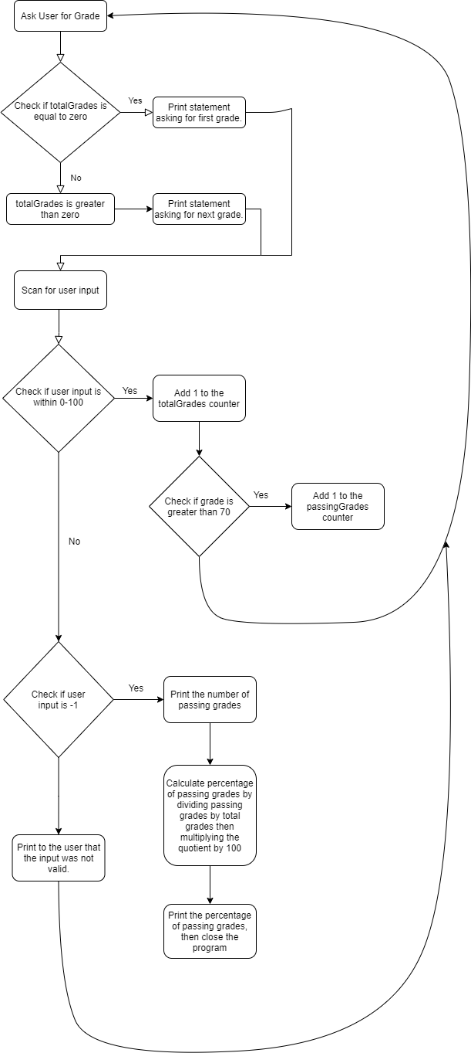

Part 4

Test Case 1

Grades Entered: Expected Results

50

79

91

23

77

84

99

67

73

105 That is not a valid grade!

-1 You entered 6 passing grades  
 66.7% of the valid grades entered are passing grades.

Test Case 2

Grades Entered: Expected Results

80

109 That is not a valid grade!

91

23

77

84

99

67

73

105 That is not a valid grade!

-1 You entered 4 passing grades  
 66.7% of the valid grades entered are passing grades.

#include<stdio.h>

#include<stdlib.h>

/*Juan Velasquez 3/2/2021

This program calculates the total number of passing grades

that the user inputs. The amount of inputs can be infinite

as the program is using a sentinel controlled while loop.

The program breaks the loop when the user inputs a -1. This

then makes the program output how many passing grades the

user inputted and the percent of grades that are passing.

*/

main()

{

//Instantiation and initialization of program variables.

int totalGrades, passingGrades, curGrade;

double percentageOfPassingGrades = 0;

totalGrades = 0;

passingGrades = 0;

curGrade = 0;

//The main sentinel controlled while loop that only breaks when the user input is equal to -1.

while (curGrade != -1) {

//Making a dedicated text output for the user when it is the first input.

if (totalGrades == 0) {

printf("What is the first grade?\n");

}

//After the first input, all other outputs of text will be this.

else {

printf("What is the next grade?\n");

}

//Scan for the users input and set the currentGrade variable equal to it.

scanf_s("%i", &curGrade);

//Check if the grade is in the valid range.

if (curGrade >= 0 && curGrade <= 100) {

//If so, add one to the total grade counter.

totalGrades++;

//Check to see iof the grade is passing.

if (curGrade >= 70) {

//If so add one to the passing grade counter/

passingGrades++;

}

}

//If the current grade is not within the range, check if is equal to -1

else if(curGrade == -1){

//If so go through the closing procedure

printf("You entered %i passing grades\n", passingGrades);

//Calculate percentage of passing grades by first parsing the intger variables into double,

//then dividing passing grades by total grades and then multiplying the quotient by 100

percentageOfPassingGrades = (double) passingGrades / totalGrades*100;

//Print out the result

printf("%.1lf%% of the valid grades entered are passing grades.", percentageOfPassingGrades);

}

//If the current range is not in the valid range or equal to -1, then tell the user that the input is invalid

else {

//Print that the input is invalid

printf("That is not a valid grade!\n");

}

}

}

